**Tidy Toiletries Case**

**Toiletry Case User Manual**

**Project Group 2**

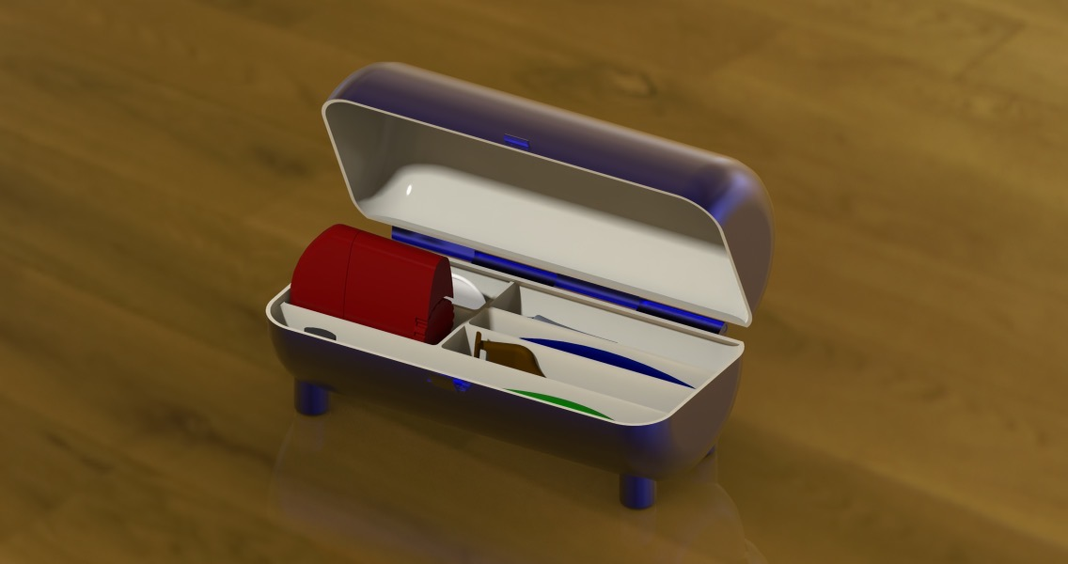

**The following manual includes assembly instructions, maintenance and use instructions, and warranty information and contacts.**

**Please read before using the Tidy Toiletry Case**

**Table Of Contents**

**Assembly** **… (1)**

**Use and Maintenance** **… (2)**

**Warranty Information** **… (3)**

**Contacts** **… (4)**

# Assembly

(1) The Tidy Toiletries Case comes with 4 components, the bottom half of the pill shaped container with the built in feet, the top half of the pill shaped container, the pin for the hinge, and the clasp. When traveling, the sleekness makes this case useful for slipping in and out of luggage and storage pockets. The bottom half of the case comes with 6 slots in which are made to the perfect size for travel size toiletries such as a toothbrush, deodorant, razor, comb, etc. The base of the case also features small feet to elevate it off of any surface, allowing all of the toiletries inside to stay clean and away from contaminants on the surface in use.

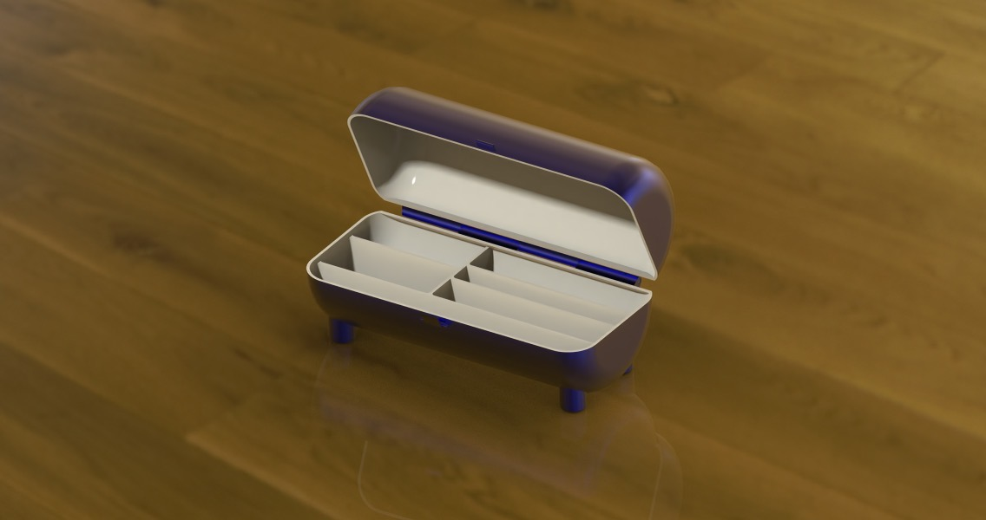

To assemble the Tidy Toiletries Case the top side of the pill shaped case (the side with no compartments) must slide in place using the hinges with the bottom of the pill shaped case. The small pin that comes with it must then be slid through the hinges, holding the two halves together, the clasp simply snaps into place then will be ready to use.

# Use and Maintenance

(2) The Tidy Toiletries Case is made from high grade plastic resistant to most all purpose home cleaners and is dishwasher safe. When dirty, simply scrub with any general purpose cleaner, or throw it in with your next load of dishes in the dishwasher. Dry afterward with a clean towel or washcloth, or allow it to air dry before use again.

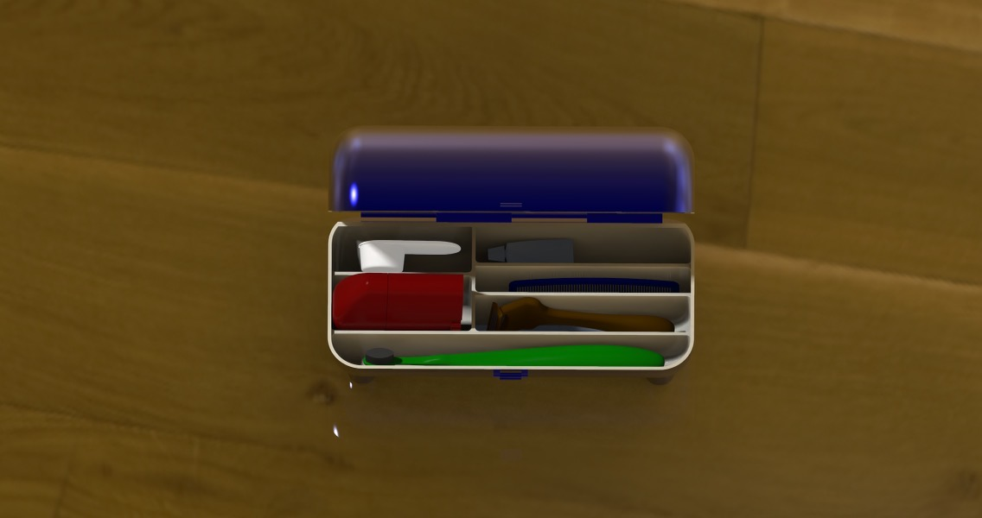

The separate compartments make travel easy, and make sure each item in the container stays separate from each other. This way moisture and contamination will stay contained in each compartment and make cleaning easier.

# Warranty Information

(3) Your purchase of the Tidy Toiletries Case includes a 30 day replacement or return policy if your case was purchased from a licensed Tidy Toiletries Case retailer. This policy guarantees that your case will come free of defects and hazards and if your product comes with defects or hazards we will send you a replacement product or give you your money back guaranteed. This warranty does not cover any damages caused by accident or misuse of the product.

# Service Center Contacts

(4) Our service center is located in Charlotte, North Carolina. For returns, the mailing address is Tidy Toiletries Case Distribution, 9201 University City Boulevard, Charlotte, NC, 28223. For questions, comments, and concerns, call our service number at 1-800-TIDYTOI or email us at any of our makers' emails.

Craig Bowman

[cbowma31@uncc.edu](mailto:cbowma31@uncc.edu)

Tyler Morris

[tmorri66@uncc.edu](mailto:tmorri66@uncc.edu)

Drew Scearce

[dscearc1@uncc.edu](mailto:dscearc1@uncc.edu)

Jaiden Hastings

[jhasti17@uncc.edu](mailto:jhasti17@uncc.edu)